Living Planet @ Campus tool kit
2023-2024 School Year

Living Planet @ Campus general communications

- Objective: Communicate to students that WWF-Canada has partnered with your campus and inform them of various activities on the campus that they can participate in.
- Hashtag: #wwfoncampus
- Account to tag: @wwfcanada (Facebook, Instagram, LinkedIn and Twitter/X)
- URL: campus.wwf.ca

Sample Copy | Asset
Partnership post  Post 1.  We're partnering with @wwfcanada on Living Planet @ Campus, a national program that helps engage students like you in environmental actions and leadership opportunities. Learn more about #wwfoncampus: campus.wwf.ca | Photo of your students taking action, or generic nature/leadership photo.  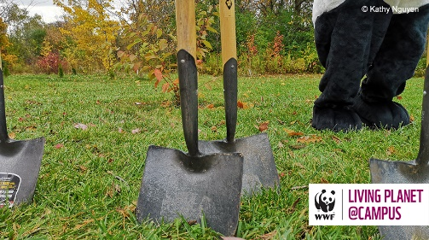
Program promo  Post 1.  Are you interested in building a future where people and wildlife thrive? Get back to nature with #wwfoncampus. Learn more 👉 campus.wwf.ca | 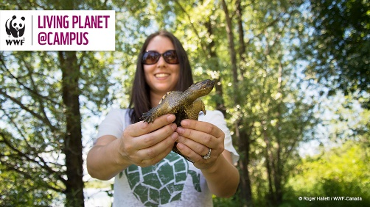
Post 2.  Earn your #wwfoncampus Living Planet Leader certification & leave [campus name] with the leadership and sustainability experience employers are looking for. campus.wwf.ca | 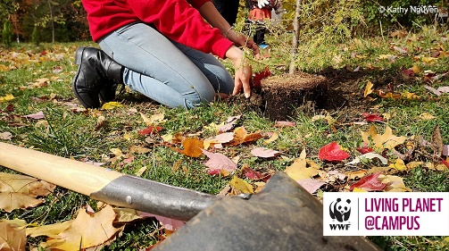
Post 3.  Interested in protecting nature for a sustainable future? You can make that difference on your campus and community. Take action with #wwfoncampus.  campus.wwf.ca | 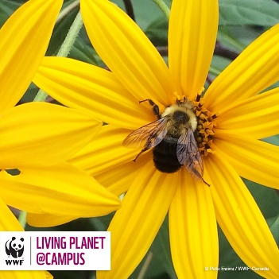
Post 4.  Don’t just learn about environmental issues and actions in the classroom. Live it and lead it with #wwfoncampus >  wwf.campus.ca | 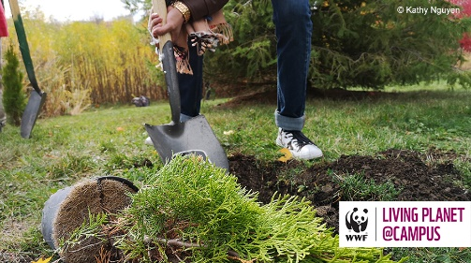
Post 5.
Are you looking for ways to take action for nature on campus? Find out how [campus name] is working with @wwfcanada at campus.wwf.ca

WWF Go Wild Grants communication

- Objective: Communicate to students that WWF-Canada has made a $2000 Go Wild Grant available for students at your campus and encourage applications.
- Hashtag: #WWFGoWild #wwfoncampus
- Account to tag: @wwfcanada (Facebook, Instagram, LinkedIn and Twitter/X)
- URL: https://campus.wwf.ca/event/go-wild-school-grants/
- Application period opens: September 7, 2023
- Application period closes: October 23, 2023 (*new extended deadline)

Sample Copy | Asset
Promote opportunity

Post 1.
[Campus name] and @wwfcanada want to help you protect and restore nature. Apply for a $2000 #wwfoncampus Go Wild Grant to lead a project today: https://bit.ly/2EId3oa

(note: add @wwfcanada in Facebook handshake if possible)
Post 2.  #DYK our campus could be a habitat? It’s as easy as planting a native tree or pollinator garden. For more ideas on how you can Go Wild with a #wwfoncampus $2000 grant, visit https://bit.ly/2EId3oa  (note: add @wwfcanada in Facebook handshake if possible) | 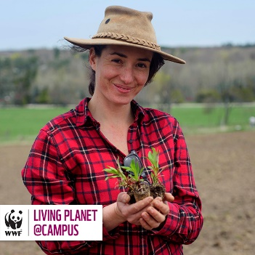
Post 3.  Do you have a project idea to help create or restore habitat? @wwfcanada has $2000 Go Wild Grants to award, and one could be yours! Apply by Oct. 23 https://bit.ly/2EId3oa  (note: add @wwfcanada in Facebook handshake if possible) | 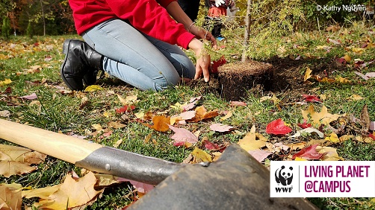
Post 4.  Become a citizen scientist, restore habitat or connect your campus with nature. The last day to apply for a $2000 @WWFCanada Go Wild Grant is Oct. 23 https://bit.ly/2EId3oa  (note: add @wwfcanada in Facebook handshake if possible) | 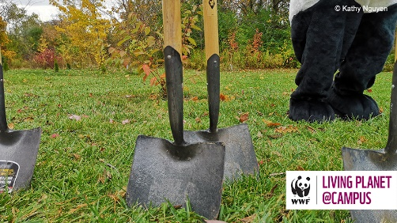
Post 5.  Team up with @WWFCanada to help create and restore habitat. Apply with your idea by Oct. 23 for a $2000 grant to kickstart your project https://bit.ly/2EId3oa | 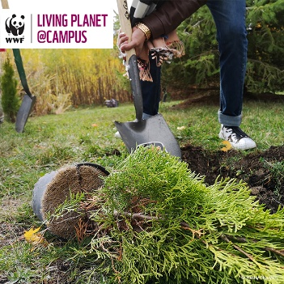

Living Planet Leader
- Objective:
  - Encourage students to sign up for the WWF-Canada Living Planet Leader certification
  - Highlight new actions that have been added to the certification, encouraging students to learn about the environment and connect with others to inspire change, in addition to taking hands-on actions for nature.
  - Celebrate Living Planet Leaders from your campus
  - Promote opportunities on campus that help contribute to Living Planet Leader requirements
- Hashtag: #wwfoncampus
- Account to tag: @wwfcanada (Facebook, Instagram, LinkedIn and Twitter/X)
- URL: https://campus.wwf.ca/event/living-planet-leader/

Sample Copy
Inspire students to sign up

Post 1.
Build a more sustainable future where people and wildlife thrive, and get recognized for it! Become a Living Planet Leader with @WWFCanada #wwfoncampus
Learn more: https://bit.ly/34k6q48
Post 2.
Help nature thrive and get credit and recognition for it with @WWFCanada’s Living Planet Leader certificate.

Learn more: https://bit.ly/34k6q48
Post 3.
Are you helping to lead sustainable activities on campus or in the community? Have you been volunteering for environmental initiatives? Get recognition on your resume and LinkedIn with @WWFCanada’s Living Planet Leader certificate. https://bit.ly/34k6q48
Post 4.
Whether it’s self-guided or through your school program, learning about the natural environment around you is a critical step towards building a future where people and nature thrive. It also contributes to a @WWFCanada Living Planet Leader certification! Record your actions and build your resume at campus.wwf.ca

Post 5.
Inspire change by inspiring others. Share a podcast that has moved you. Invite your family to a tree planting. Visit your local native plant nursery with roommates and build a container garden for nature. When we encourage others to learn, discover, and take action with us, we are creating positive change for nature. Record the change you’re creating at campus.wwf.ca for the opportunity to become a @WWFCanada Living Planet Leader.

Post 6.
Hey, students! #DYK that many actions you take every day can count towards @WWFCanada’s Living Planet Leader certification? Visit campus.wwf.ca to learn more!
Post 7.
Are you a part of an environmental student or community group? #DYK that your hours can count towards the @WWFCanada Living Planet Leader designation? Visit campus.wwf.ca to learn more!
Post 8.
Did you know that you can add your @WWFCanada Living Planet Leader certification on your LinkedIn profile? Sign up today at campus.wwf.ca and show future employers that you’re a sustainability champion!
Post 9.
#DYK you don’t have to be enrolled in a sustainability-related degree to complete @WWFCanada’s Living Planet Leader certification? Visit campus.wwf.ca to learn more!
Promote campus opportunities to complete Living Planet Leader

Post 1.
[Description of your activity/opportunity here]. Join us and earn requirements for @WWFCanada’s Living Planet Leader certificate.
Promote the first official Living Planet Leader from your campus

Post 1.
Congratulations to [STUDENT NAME], [PROGRAM], our first @WWFCanada Living Planet Leader from [CAMPUS NAME]!
Celebrate a new official Living Planet Leader from your campus

Post 1.
Congratulations to [STUDENT NAME], [PROGRAM], our newest @WWFCanada Living Planet Leader from [CAMPUS NAME]!

